Build a Scarecrow
Little Chalfont Village Day Scarecrow Competition
15th June 12pm – 4pm

Adults (over 15) or children, alone or with friends, schools and businesses all welcome to showcase your talent in scarecrow making. Entry is FREE! Application forms are available in Little Chalfont Community Library or online at www.littlechalfont.org.uk or lcevewi@gmail.com
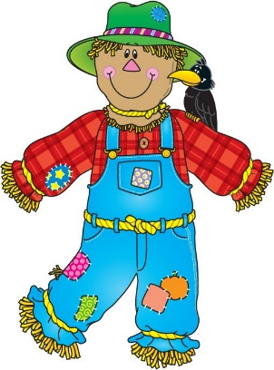
Prizes will be awarded on a public vote in the Village Hall

If you have any further enquires please contact lcevewi@gmail.com
Thank you

