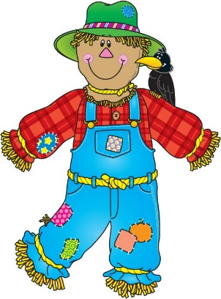
Little Chalfont Village Day Scarecrow Competition
15th June 12pm – 4pm

Entry Form
Name/School/Organisation* …………………………………………………
*Delete as appropriate
Contact Name………………………………………………………………………..
Contact Number…………………………………………………………………….
Email Address………………………………………………………………………..
………………………………………………………………………………………………
Category*
*Delete as appropriate

Class 1 Under 15
Class 2 over 15

Please remember that your Scarecrow needs to be free standing.
Entrants must come to the Island in front of the Chemist by 10.30 om Village Day to be allocated space for their scarecrow, with a photo of their scarecrow (no larger than A4) this is so the public can be sure of which scarecrow they are voting for in the village hall.
Entrants will need to remove their scarecrow at the end of Village Day.
If you have any further enquires please contact lcevewi@gmail.com
Thank you

